**A1348-ME-Uruk-Lion-Figurine-Limestone-2100 BCE**

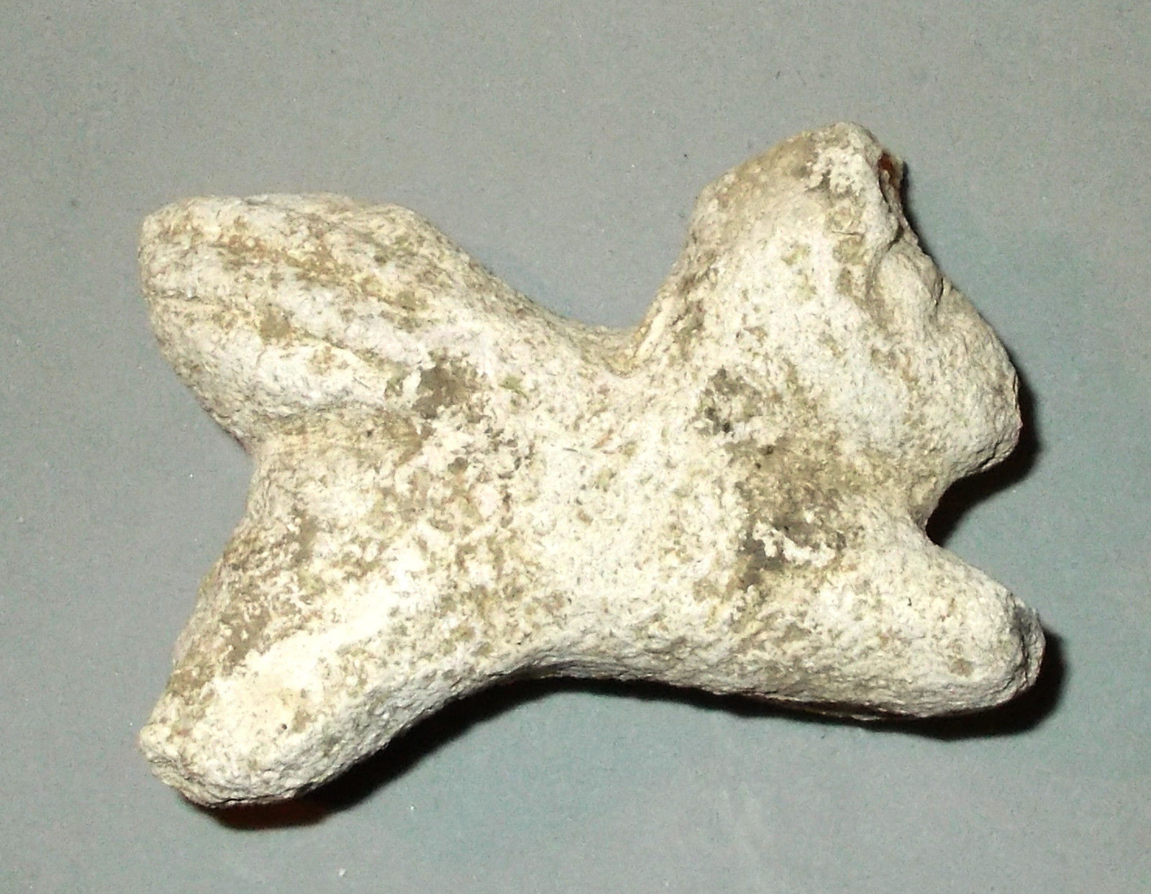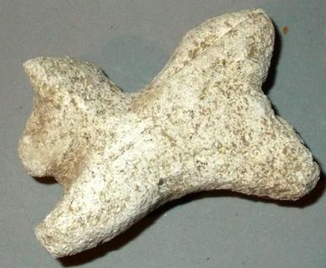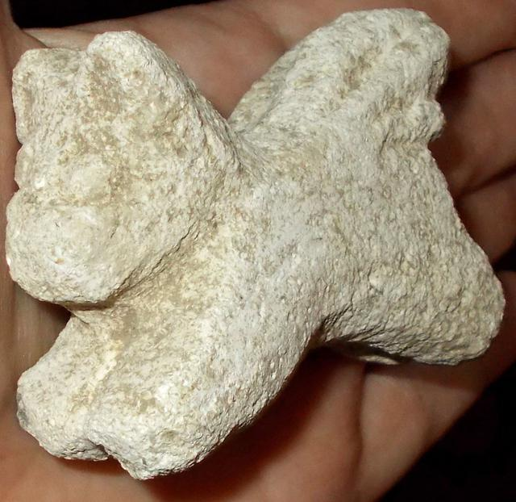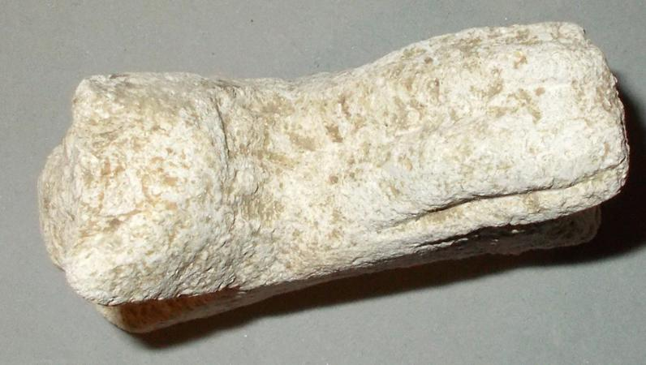

**Figs. 1-3**. **Uruk-Lion-Figurine-Limestone-2100 BCE**

**Case no.: 4**

**Accession Number:** A1348

**Formal Label**: **Uruk-Lion-Figurine-Limestone-2100 BCE**

**Display Description:**

This Winged Lion Figurine in Limestone dating to 2100 BCE of the Akkadian Period corresponds to the period when Ishtar was often depicted as a heavily armed warrior goddess, frequently accompanied by lions (Black and Green, p. 119).  Lions were among the many symbols Ishtar adopted from the Sumerian goddess Inanna (Collins 1994, pp. 113-11).

**LC Classification**: DS62.23.U78

**Date or Time Horizon**: ca 2100 BCE

**Geographical Area:** Uruk

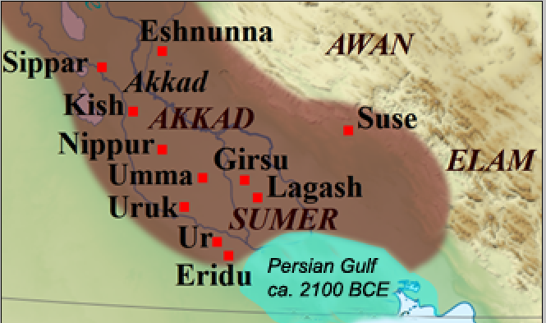

**Fig. 4.** Map of Sumer and Akkad, ca 2100 BCE

**GPS coordinates:** Uruk, 31°19′27″N 45°38′14″E

**Cultural Affiliation:** Sumerian

**Medium:** limestone

**Dimensions:** 7.1cm long X 6cm tall X 23mm wide  (2 3/4" X 1 7/8")

**Weight:**

**Condition:** original

**Discussion:**

The lion sculpture has had a long and obscure history, which may have begun in Egypt ca 3000 BCE and diffused from there to western Asia’s winged lion-griffin statue on a monument to the god Sandon at Tarsus in Cilicia (Southern Turkey) ca 300 BCE.

**Provenanc**e: old English Collection

**References:**

Black, Jeremy; and Anthony Green. 1992. *Gods, Demons and Symbols of Ancient Mesopotamia: An Illustrated Dictionary*. London: The British Museum Press.

Collins, Paul. 1994. "The Sumerian Goddess Inanna (3400-2200 BC)", *Papers of from the Institute of Archaeology*, 5. London: UCL.

DDD. 1999. *Dictionary of Deities and Demons in the Bible. DDD*. Ed Karel van der Toorn, Bob Becking, Peter W. Van der Horst. Second ed, Boston: Brill.

Guirand, Felix.1968. "Assyro-Babylonian Mythology," *New Larousse Encyclopedia of Mythology*. Translated by Ames Aldington. London, England: Hamlyn, pp. 49–72.

Kramer, Samuel Noah. 1963. *The Sume*rians. Chicago: University of Chicago Press.

Parpola, Simo. 2004. "Assyrian Identity in Ancient Times and Today" <http://www.nineveh.com/parpola_eng.pdf>

Wilkinson, Philip (1998), *Illustrated Dictionary of Mythology*. New York: Dorling Kindersley.